SF.SmokeTestScripts_TC_SF_OBAccountsLandingPage_Instance1_17-Apr-2017_11-29-09_PM_Invoke_Application.png



SF.SmokeTestScripts_TC_SF_OBAccountsLandingPage_Instance1_17-Apr-2017_11-29-22_PM_Login.png

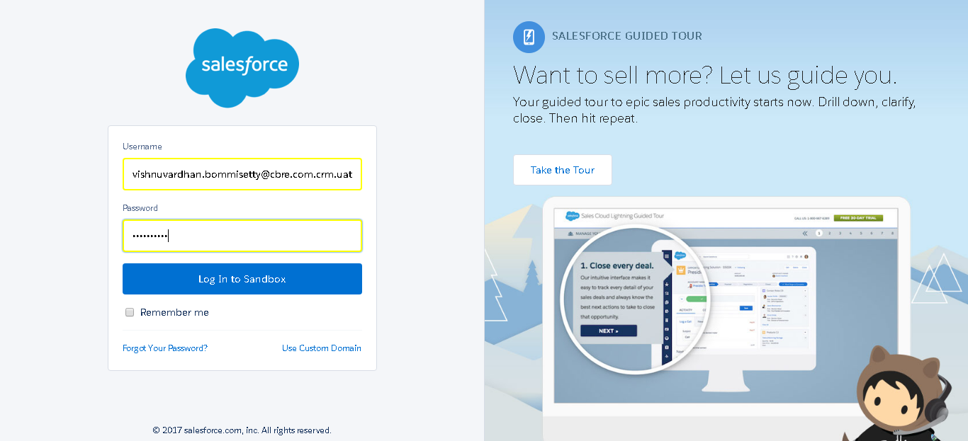

SF.SmokeTestScripts_TC_SF_OBAccountsLandingPage_Instance1_17-Apr-2017_11-29-39_PM_Verify_Login.png

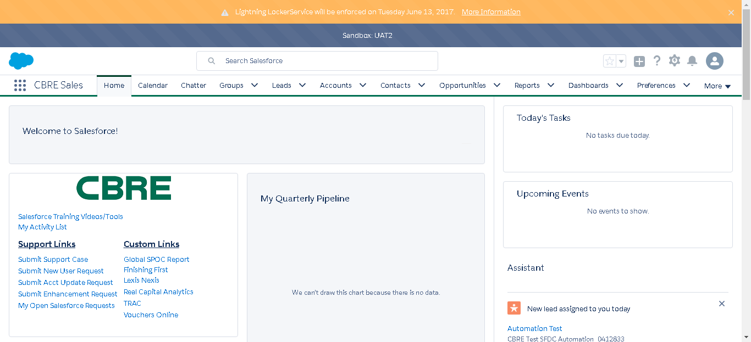

SF.SmokeTestScripts_TC_SF_OBAccountsLandingPage_Instance1_17-Apr-2017_11-29-43_PM_Verify_Menu_-_Accounts.png

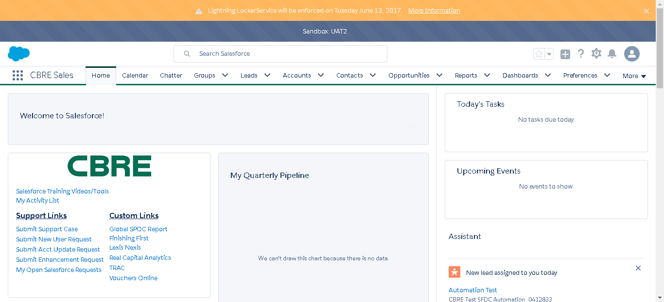

SF.SmokeTestScripts_TC_SF_OBAccountsLandingPage_Instance1_17-Apr-2017_11-29-46_PM_Verify_Accounts_Home_Page.png

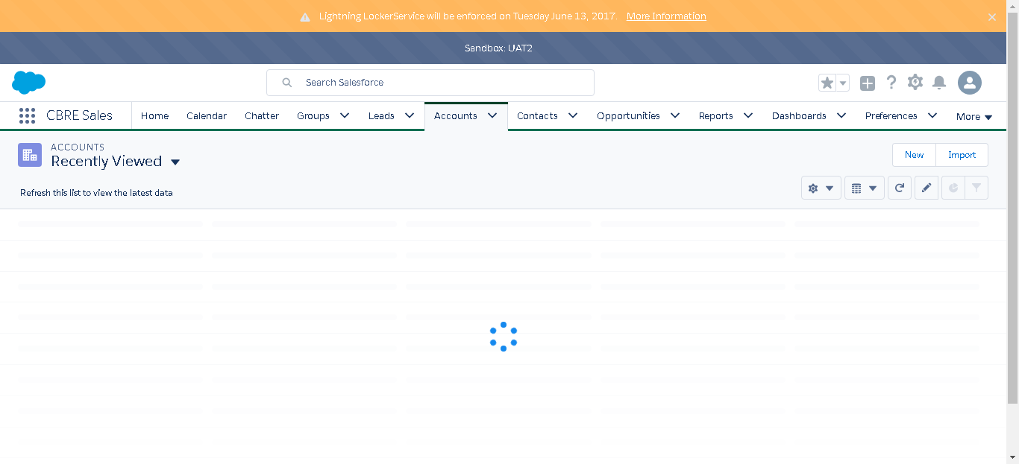

SF.SmokeTestScripts_TC_SF_OBAccountsLandingPage_Instance1_17-Apr-2017_11-30-09_PM_Verify_Account_Landing_Page_Inform

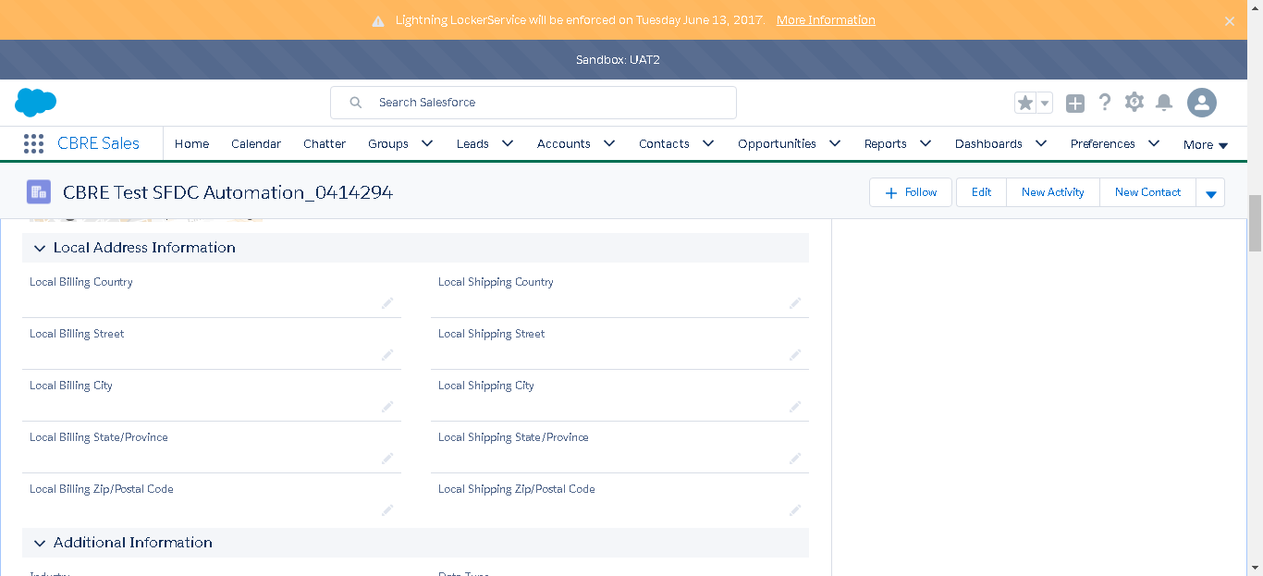

SF.SmokeTestScripts_TC_SF_OBAccountsLandingPage_Instance1_17-Apr-2017_11-30-10_PM_Verify_Account_Landing_Page_Inform



SF.SmokeTestScripts_TC_SF_OBAccountsLandingPage_Instance1_17-Apr-2017_11-30-11_PM_Verify_Account_Landing_Page_Inform



SF.SmokeTestScripts_TC_SF_OBAccountsLandingPage_Instance1_17-Apr-2017_11-30-12_PM_Verify_Account_Landing_Page_Inform



SF.SmokeTestScripts_TC_SF_OBAccountsLandingPage_Instance1_17-Apr-2017_11-30-13_PM_Verify_Account_Landing_Page_Inform



SF.SmokeTestScripts_TC_SF_OBAccountsLandingPage_Instance1_17-Apr-2017_11-30-14_PM_Verify_Account_Landing_Page_Inform

